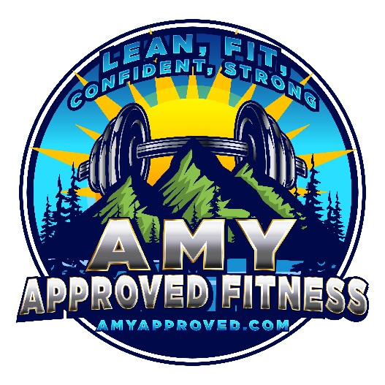
Amy Approved Fitness
Personal Training
amy@amyapproved.com
805-234-2780
AmyApproved.com
Personal Training Health Screening Questionnaire
Personal Information
Today’s date: _________________
Name: ______________________________
Birth date: _______________
Age: ____________________
Address: _________________________________
Email: ___________________________________
Phone / Cell: _______________________________
Occupation: _______________________________
Gender: Male______ Female _______ Height: ______ Weight: _________
Person to contact in case of emergency: _____________________________
Tel: ___________________
Physician’s Name: ____________________________
Tel: ________________________________

Medical History
Please indicate if any of these statements apply to you by placing a YES in the space provided (*past or current):
- History of heart problems or stroke
2. Diabetes Mellitus
3. Asthma, breathing or lung problems
4. Allergies
5. Cancer (other than skin)
6. Seizures, seizure medication, neurological problems or dizziness
7. High blood pressure
8. Back problem, joint or muscle disorder still affecting you
9. Recent surgery (last 12 months)
10. Hernia or any condition that may be aggravated by exercise
11. Physician’s advice not to exercise
12. History of high cholesterol
13. Family history of coronary heart disease
14. Do you smoke tobacco products?
15. Do you consume alcohol?
16. Do you take supplements of any kind? – please list
17. Are you on medication?
18. Do you have a joint problem that might be aggravated by exercise?
19. Have you been diagnosed with Osteoporosis?
20. Is stress from daily living an issue in your life?
Skeletal Injuries
Back ____________________________________________
Neck_____________________________________________
Head _____________________________________________
Knee (R,L) _________________________________________
Shoulder (R,L) _______________________________________
Other injuries: _______________________________________
Surgery: ___________________________________________
Please describe any special considerations or how your injury currently affects your ability to function: (i.e. illness or injury)
__________________________________________________
__________________________________________________
Goals
- What are your concerns & goals? (examples: fat loss, strength, power, muscular endurance, cardio fitness, flexibility, agility, core stability or balance)
___________________________________________________
___________________________________________________
___________________________________________________
- Why do you want to achieve these goals? (ex: general health, injury prevention/rehab, sport-specific training)
____________________________________________________
_____________________________________________________
- Which criteria will you use to measure the effectiveness of this program? (ex: body measurements, %body fat, sport-specific goals, increased energy levels, bone density test, stress reduction, inches)
_____________________________________________________
- What areas do you want to concentrate on or emphasize? (i.e.: specific areas to strengthen, joint stability, cardio or core conditioning, specific areas to mobilize)
_____________________________________________________
Fitness History
- How long has it been since you have exercised regularly?
_____________________________________________________
- Do you have experience with free weights or functional stability training?
______________________________________________________
- What type of cardiovascular exercise are you familiar with?
_________________________________________________________
- If you are an experienced exerciser or athlete, what is your current program?
___________________________________________________________
- Are there any exercises that are contraindicated or not recommended by your physician or physical therapist?
_________________________________________________________

Lifestyle

- How would you describe your level of daily activities?
Light (office work) ____ Moderate (manual labor) ____ Heavy (construction) ____
- Stress (high=5, low=1)
Physical 12345 Personal/Emotional 12345 Mental/Career 12345
- Present method of handling stress:
_________________________________________________________
- Number of hours of sleep per night? __________________________
- What is your available time & frequency for exercise?
What days: M T W Th F
What times: am_________ pm__________
- Any special considerations or requests?
_________________________________________________________

Total Release and Waiver of Liability

As a condition of my enrollment, I accept full and complete responsibility for my own ability to healthfully participate in this program. I understand that participation and use of instruction, programs, activities, services, facilities, and equipment provided is potentially hazardous.
I hereby release Amy Harper from any responsibility or liability for any injury, damage or any loss whatsoever.
I have read and understood the above and understand that it sets out the terms of engagement, and that it is also a total release, and waiver of liability.
Client Signature:_______________________ Date:_________________
Trainer Signature: ____________________ Date: _________________

Amy Approved = Creating Harmony through Fitness & Whole Foods…



